**Experiment: 1**

PART A

(PART A: TO BE REFFERED BY THE STUDENTS)

**Aim:** To implement the following in R

a. Data types, variables, operators and decision making

b. Data Structures: vectors, matrices, arrays, list and data frame

**Learning Outcomes: Learner should be able to**

1. Apply R programming to create variables with different data types and use operators.
2. Prepare basic codes related to R Objects
3. **Task 1:** Create three different vectors containing numeric data, character data and logical data. Display the content of the vectors and its type.
4. **Task 2: Create a vector with some of your friend’s names**

i. Get the length of above vector

ii. Get the first two friends from above vector

iii. Get the 2nd and 3rd friends

iv. Sort your friends by names using 2 methods

1. **Task 3:** create a 4 x 5 matrix, 3 x 2 matrix with labels, fill the matrix by rows and 2 × 2 matrix with labels, and fill the matrix by columns.
2. **Task 4:** Create three vectors x,y,z with integers and each vector has 3 elements. Combine the three vectors to become a 3×3 matrix A where each column represents a vector. Change the row names to a,b,c.
3. **Task 5:** Using functions of R, find and display **sum, mean and product** of a given vector’s elements.
4. **Task 6:** Carry out addition and subtraction of two matrices of an order n x (n-1).
5. **Task 7:** Create a “list” comprising of a vector, a matrix and a list; and give “names” to the elements in the list. Display the second element of the list.
6. **Task 8:** List all the observations of “iris” dataset, print its summary, print summary of only sepal length column, filter data only for setosa species column
7. **Task 9:** Create a table 1 of 7 observations having columns Roll number, Name and MTT1 marks
8. Add one more column of MTT2 marks in table1
9. Create same table2 for 3 more students who are late admitted.
10. Combine Table1 and Table2
11. Print the summary of new table
12. Extract only roll number and MTT2 marks from new table
13. Extract only first two rows of new table
14. Extract 3rd and 5th rows with 2nd and 3rd columns

**Theory:**

**Please refer to the resources shared during the lab.**

PART B

(PART B: TO BE COMPLETED BY STUDENTS)

Students must submit the soft copy as per following segments within one week of the practical. The soft copy must be uploaded on the **Teams**. The filename should be **PS_batch_rollno_experimentno Example: PS_A_B001_Exp1**

|  |  |
| --- | --- |
| **Roll No.: A251** | **Name: Dnyaneshwar S Borse** |
| **Prog./Yr/Sem: B.Tech/II/IV** | **Batch: B** |
| **Date of Experiment: 14-01-2025** | **Date of Submission: 15-01-2025** |

**Task 1:**

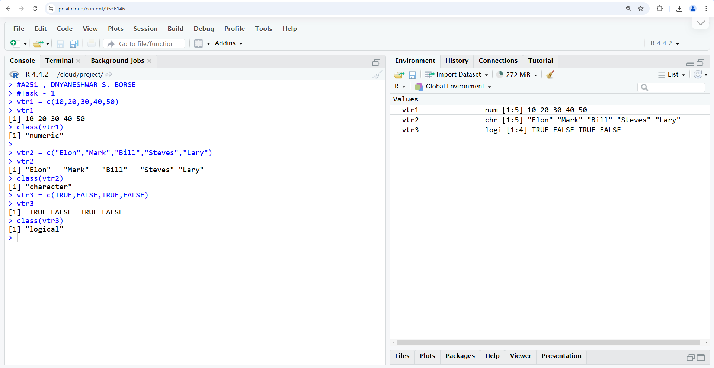

**Task 2:**

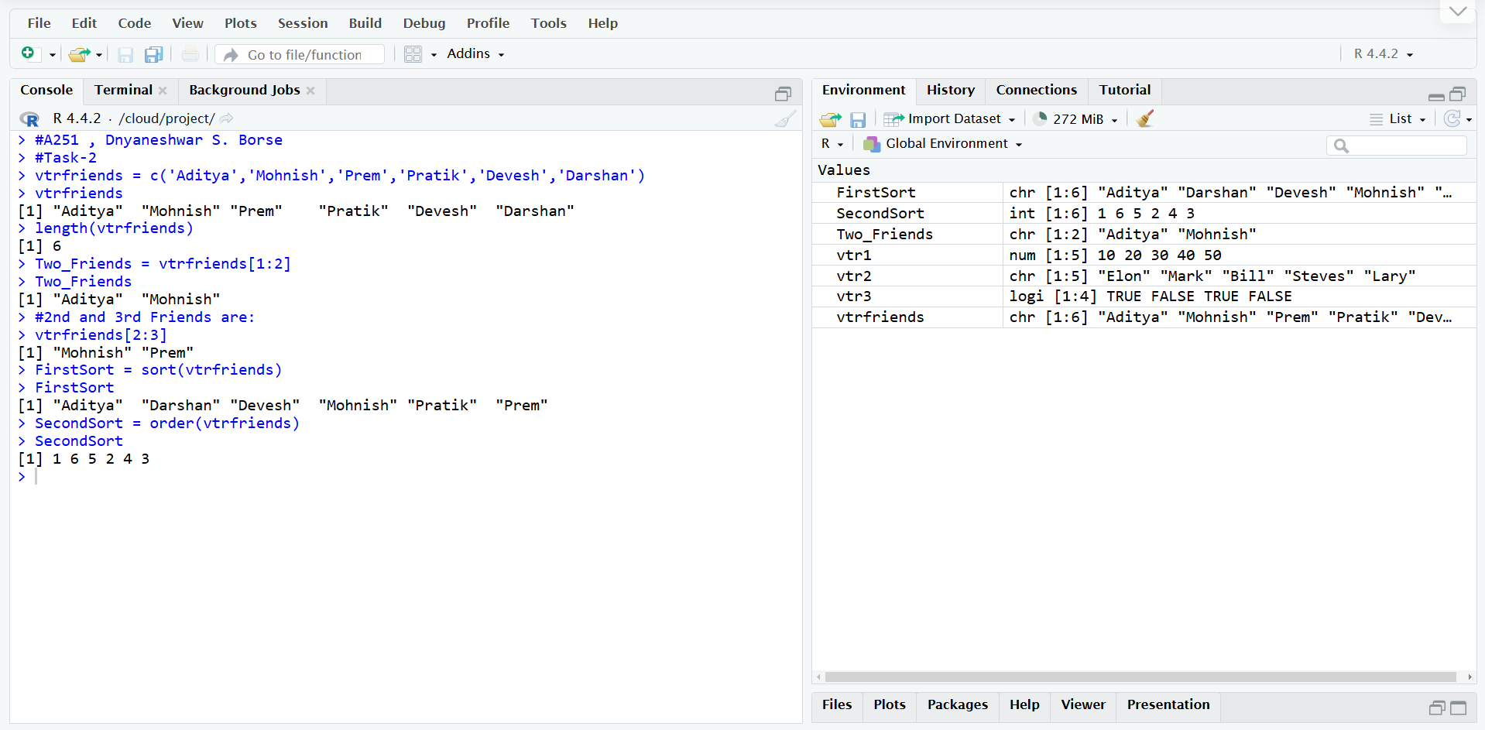

**Task 3:**

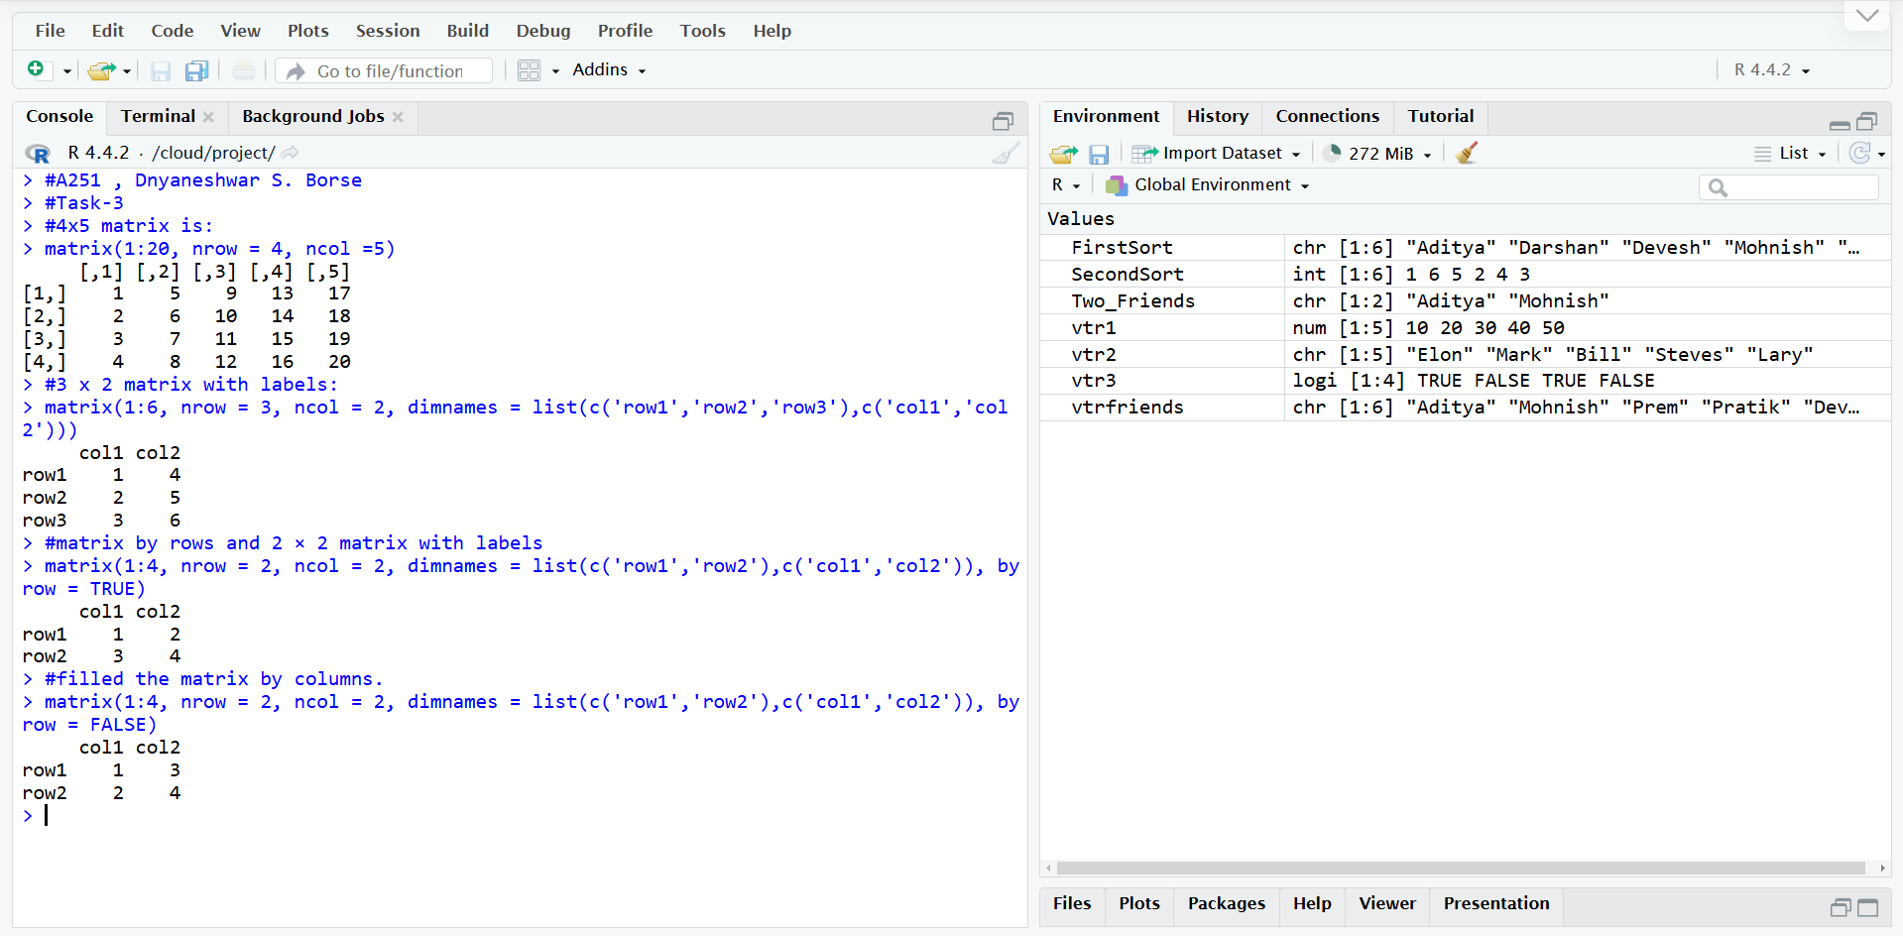

**Task 4:**

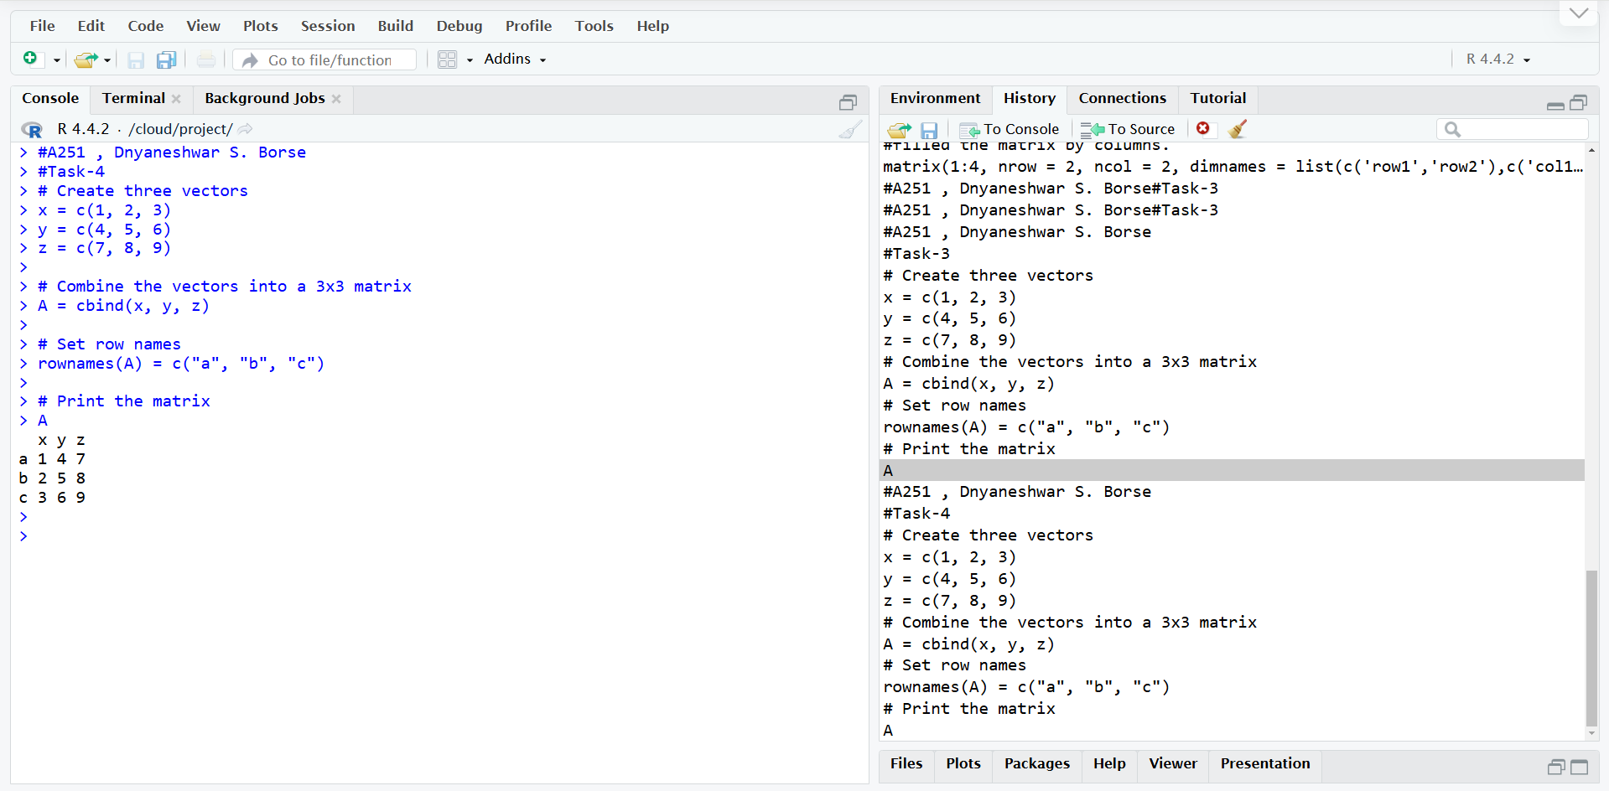

**Task 5:**

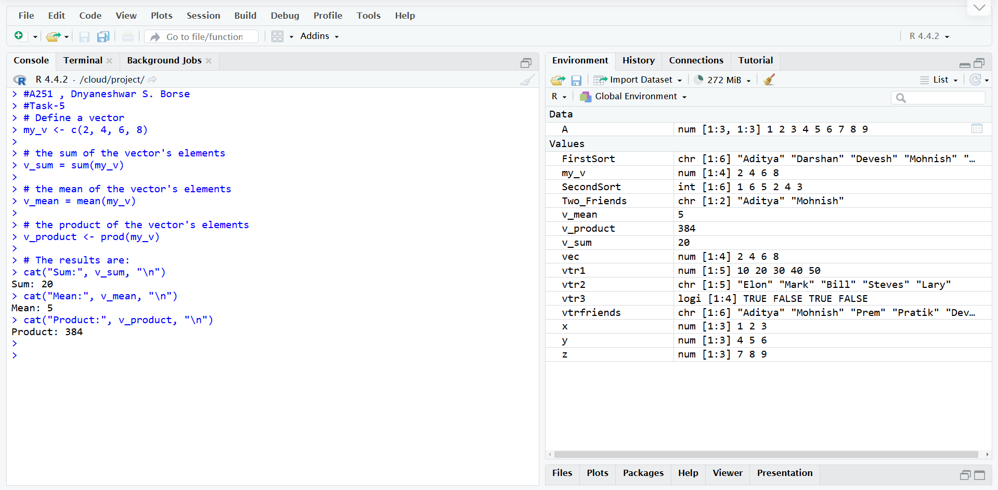

**Task 6:**

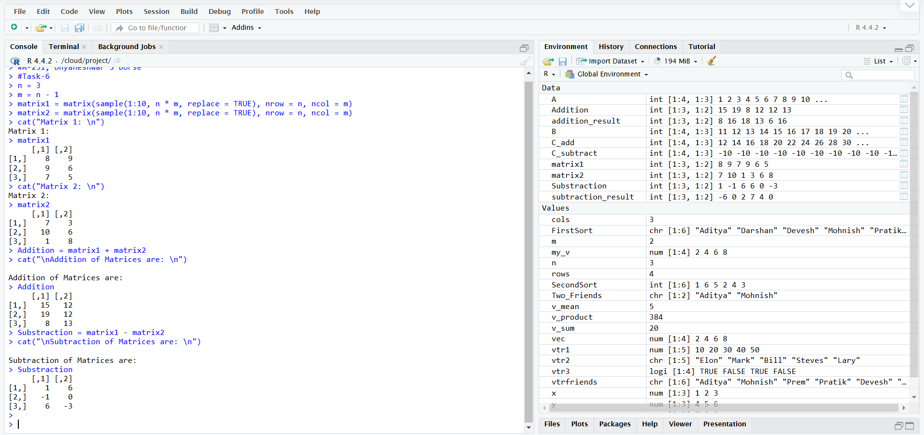

**Task 7:**

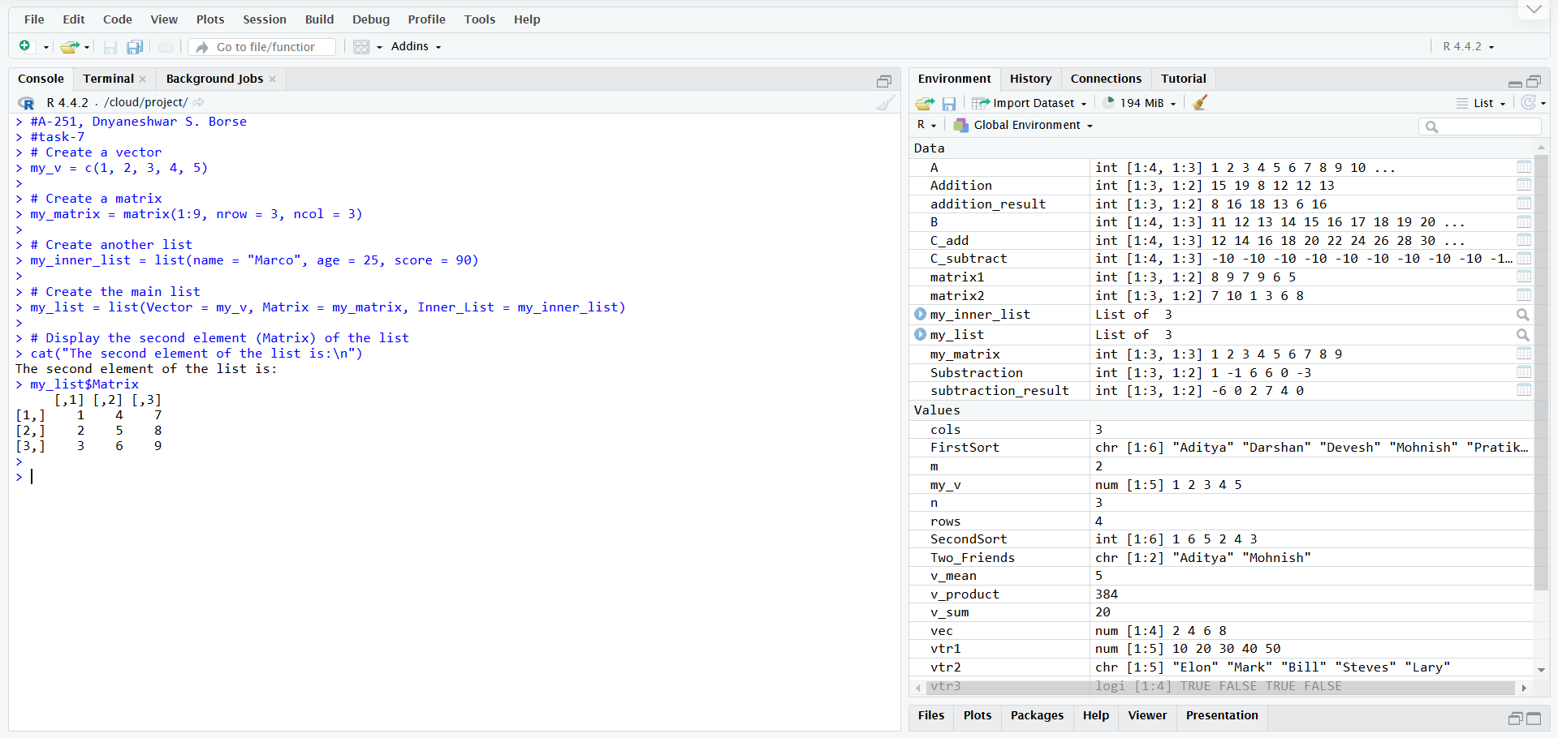

**Task 8:**

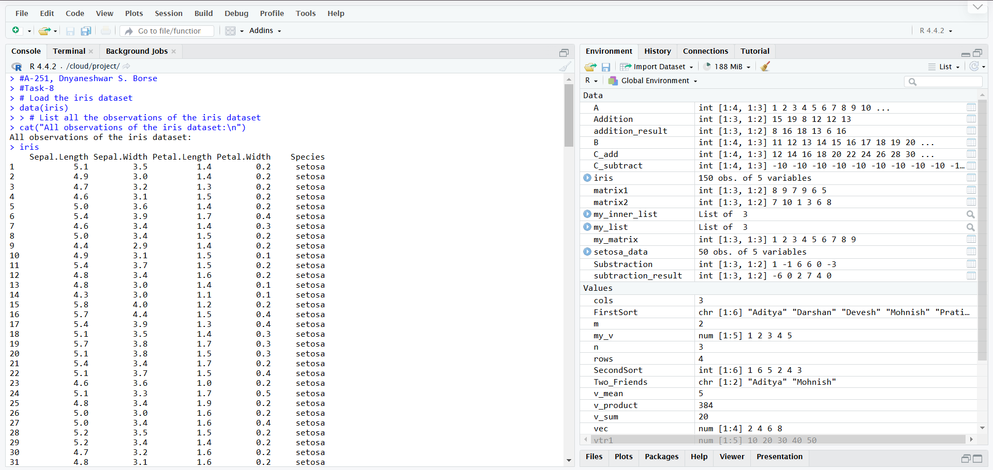

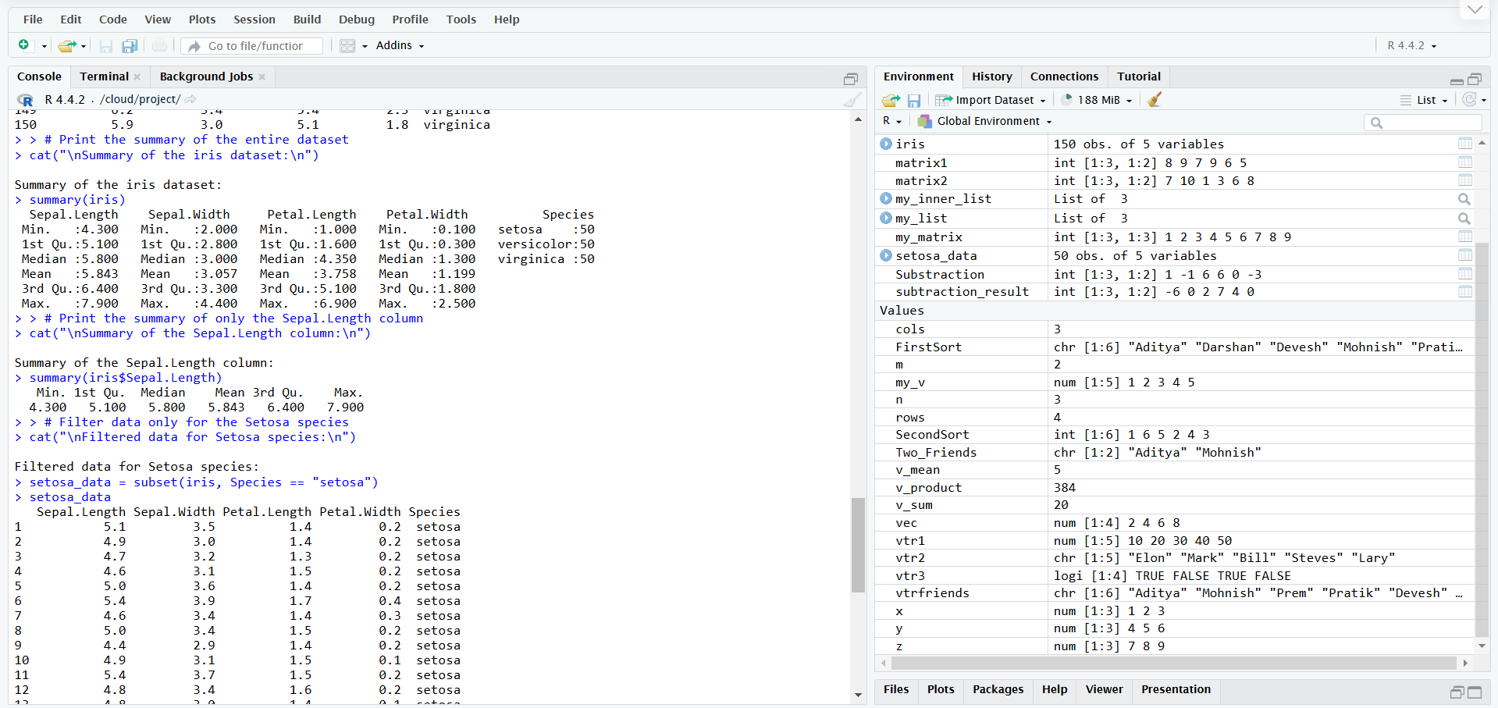

**Task 9:**

